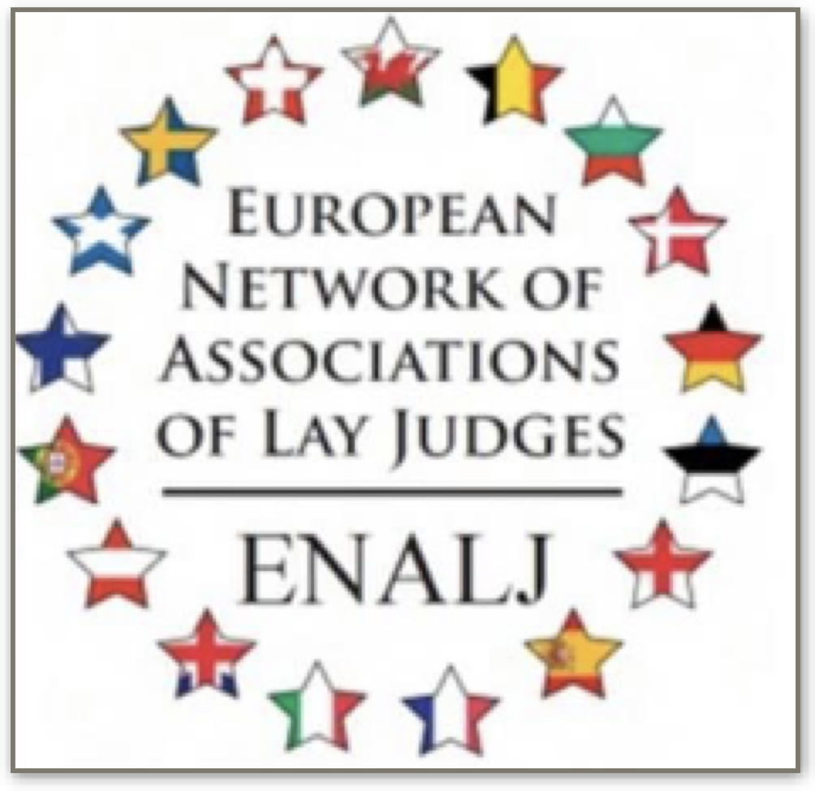

ENALJ CONGRESS

BERGAMO 9-11 MAY 2025

PROGRAMM

9 may

18,00 reception participants at “Casa del Giovane” Bergamo

20,00 welcome dinner (location to be confirmed)

10 may

9,00 Registration

9,10 Greetings from Rainer Sedelmayer - President of Enalj

9,15 Greetings from the authorities present

9,30 Greetings from component Superior Council of Magistracy

9,45 Avv. Sabrina Ghezzi (Adjunct lecturer in family law at the University of Bergamo) Juvenile court - hearing of minors and honorary judges

10,00 Reform of the honorary judiciary end of the figure of unprofessional judge or towards a new beginning - dott.ssa Rosita Silvestre ricercatrice Università Vanvitelli

10.15 The Reform of the Italian Honorary Magistracy LAW No. 51 of 15 April 2025 - dott.ssa Alessia Perolio Honorary Judge Court of Mantua – Unimo

10,30 Presentation and resolution on the admission of new members

Association of Polish Lay Judges - SŁP

DVS Federal Association of Northrhine-Westfalia

10,35 report from delegates – General assembly – part 1

11,00 Coffee break

11,30 Reports from delegates- General assembly – part 2

13,00 lunch

15,00 General assembly (including  -discussion of the point of agenda )

-Reports from delegates - General assembly part-3

- 17,00 end of General Assembly

18,00 guided tour of the city of Bergamo

20,00 Dinner in a typical restaurant Trattoria da Giuliana

11 may

9,00 visit to the Sanctuary of ‘Sotto il Monte’ birthplace of Pope John XXIII

12,00 lunch in a typical restaurant

15,40 return to Bergamo